**Basic Address book, for adding, deletion, updating, search and listing of all address via simple menu systems**

PAVITHRA C

UID:293947

FATHIMA H

UID:293954

Basic Address Book:

* Adding permanent address
* Deleting permanent address
* Updating permanent address
* Listing permanent address
* Searching permanent address

**Purpose:**

An address book is a book, or a database used for storing entries, called Address. Each address entry usually consists of a few standard fields (for example: name of a person, house no, street, district ,state).

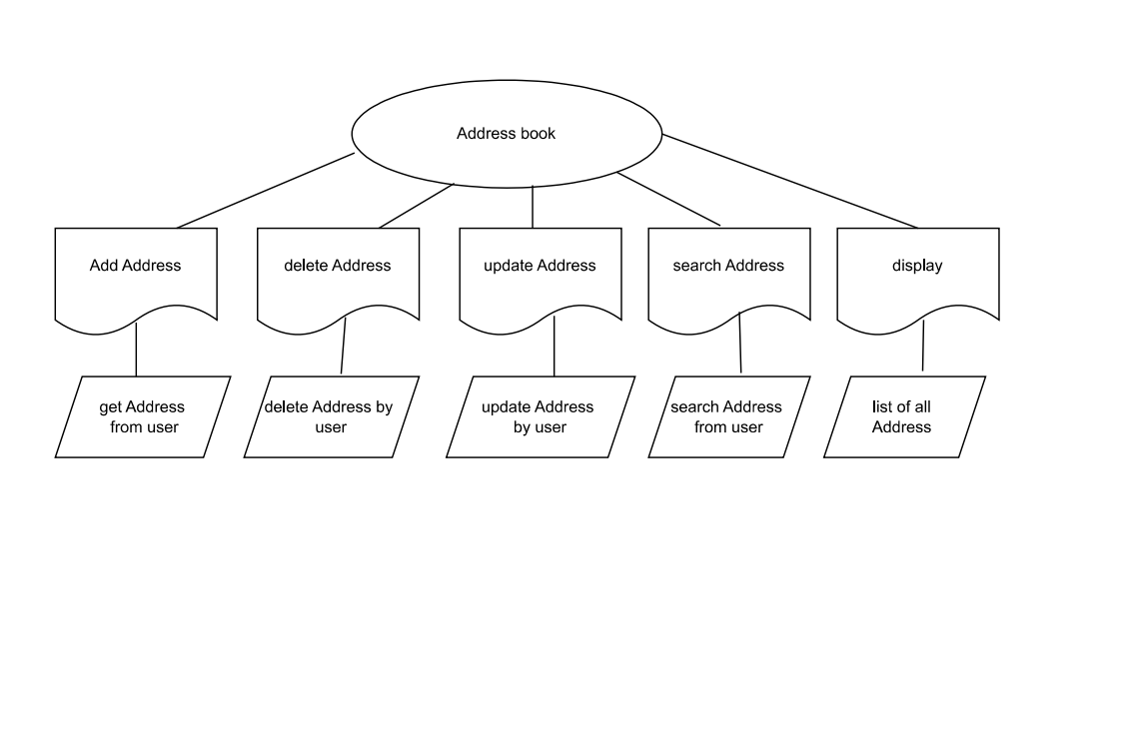

1. **Adding Address:**

User is inputting multiple address, in which it contains name of a person, address includes street, house no, district, state.

1. **Deleting Address:**

This function helps the user to delete one user’s input at a time.

1. **Search Address:**

User can search the address of a person using key element as name.

1. **Update Address:**

User can update their details using the update function.

1. **Display Address:**

Display Address helps in listing all the user’s address.

THANK YOU